Making a Decision with IF-Else
IF Statement
If statement is one of the control flow statement. In Java, If statement is used make decision based on condition.
In If statement we test a condition, if the condition is true, the code inside “If block” will be executed and if the condition is false, the code inside if the condition is ignored. Braces “{ }” decides the scope of if statement.
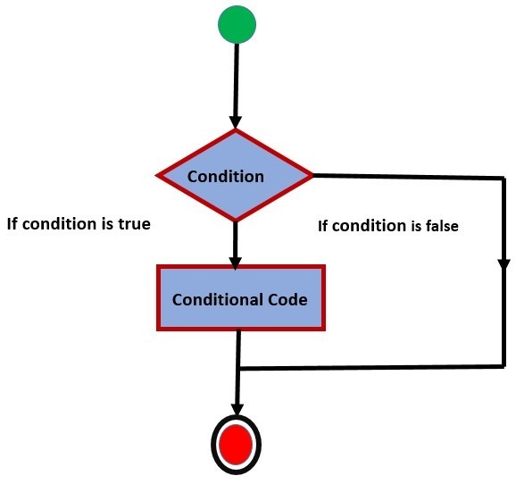
Syntax for If statement:
if(condition) {
statement1...
statement2...
}
In the following example, if the value of int x equals to 5 then statement inside “If block” will be executed.
public static void main(String[] args) {
int x = 5;
if (x == 5) {
System.out.println("Value of x is 5");
}
}
Output: Value of x is 5
If the condition is false then statement inside if block is will be ignored and code outside the scope of “If block” will be executed.
public static void main(String[] args) {
int x = 6;
if (x == 5) {
System.out.println("Value of x is 5");
}
System.out.println("What Happened");
}
Output: What Happened
IF-Else Statement
An if statement can be followed by an optional else statement, which executes when the Boolean expression is false.
“If” block would be executed when the condition is true (if x is equal to 5), otherwise “else” block is executed when the condition is false (value of x is greater than 5. Which will execute the ‘else’ block).
public static void main(String[] args) {
int x = 6;
if (x == 5) {
System.out.println("Value of x is 5");
}else {
System.out.println("Value of x is not 5");
}
}
Output: Value of x is not 5
Example 2:
package firstJavaApp;
public class App {
public static void main(String[] args) {
// Find the greater number
int n1 = 99;
int n2 = 89;
int n3 = 99;
String msg;
msg = ((n1 == n2) && (n3 < n1)) ? n1 + " & " + n2 + " are equal & greater than " + n3
: ((n1 == n3) && (n2 < n1)) ? n1 + " & " + n3 + " are equal & greater than " + n2
: ((n2 == n3) && (n1 < n2)) ? n2 + " & " + n3 + " are equal & greater than " + n1
: (n1 > n2 && n1 > n3) ? n1 + " is greater"
: (n2 > n3) ? n2 + " is greater" : n3 + " is greater";
System.out.println(msg);
}
}

